C7042 Scalextric Digital 6 Car Advanced Powerbase Aux to USB Cable 9-Mar-2012

This cable is an RS485 Aux RJ11 to USB converter. This is different from the cable that is used on the old 6 Car Powerbase C7030, which is 5V level RS232.

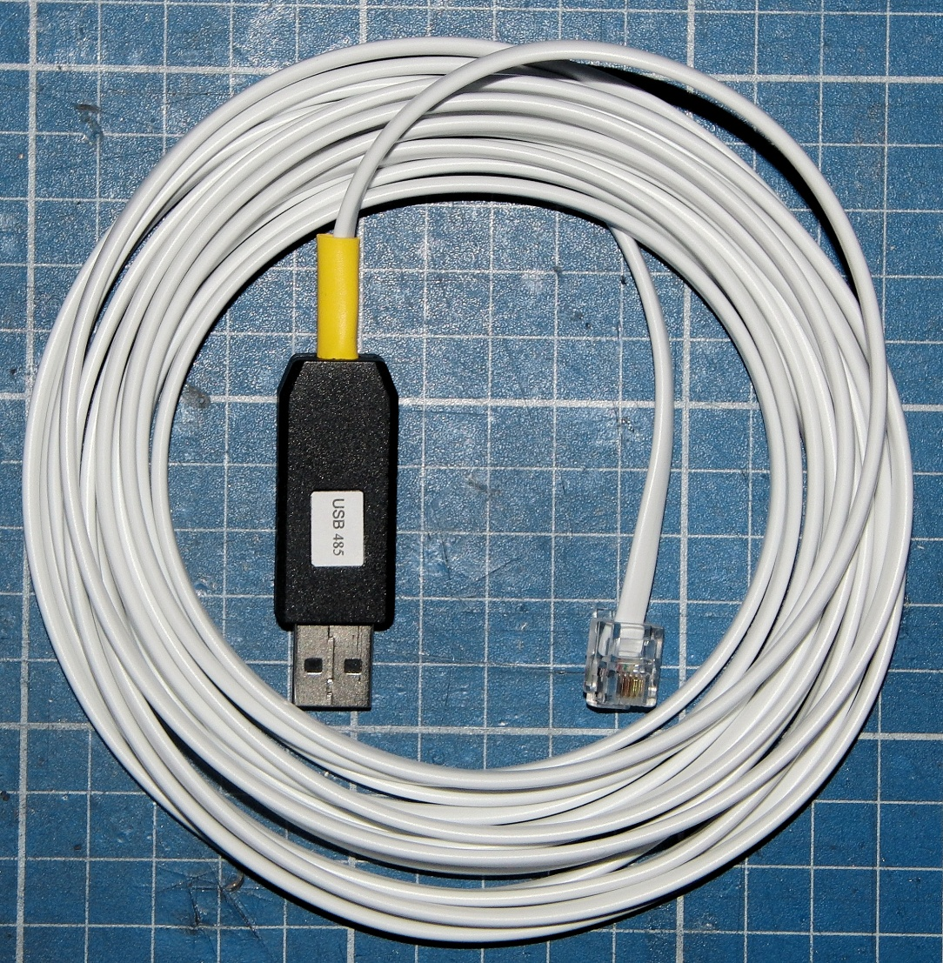

Cable is suitable for connection to the Race Management Programs and for reprogramming the firmware in the C7042 Powerbase.

A VCP Driver from FTDI is required for the PC

Aux to USB lead, based on the FTDI chip, drivers available for all operating systems.
http://www.ftdichip.com/Drivers/VCP.htm

Here is a link to the Installation Guides.
http://www.ftdichip.com/Documents/InstallGuides.htm

For Race Management, Firmware Downloads & the firmware Download Program see.
http://ssdc.jackaments.com/

Alternative Race Management from
http://pclapcounter.be/

Note.Cables have protection diodes fitted however the RS448 Interface chip can be damaged by unplugging at the Powerbase end when the Powerbase is powered up. Always Plug & Unplug with Power removed from the Powerbase.
Ordering

Price is £23.00 GBP for a 1 Meter lead..

For 2 Meters £23.50 GBP
For 3 Meters £24.00 GBP
For 4 Meters £24.50 GBP
For 5 Meters £25.00 GBP

.Longer lead lengths are possible, please add 50P / Meter.

Postage to the UK First Class add £1.00 GBP
Postage to rest of World, Air Mail, add £2.00 GBP

Payment by PayPal to richard@girling.net
Please include name & address.

When ordering please specify cable length & that you require a lead for C7042

If available please select the Personal payment owed tab as this saves the Paypal fee.
Your address is not included automatically with a Personal Payment, please add it in the text.

